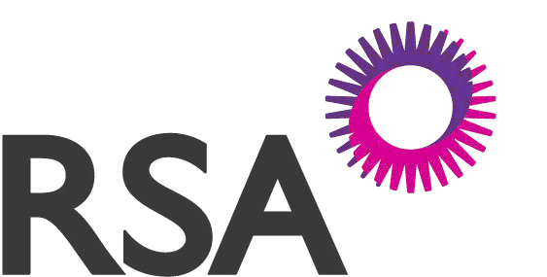
Public Liability Accident Report Form
Law Society House
90-106 Victoria Street
Belfast
BT1 3GN
Tel: (028) 9034 8529
Fax: (028) 9032 7592
Email:commericalclaims@ni.rsagroup.com
Web: www.rsagroupni.com
This is a confidential document between the Insured and the Insurers prepared for the use of the Company’s Solicitors in anticipation of litigation

SECTION A EMPLOYER (This section must be FULLY completed)
Name of Insured |  |  |  |  |  |  |  |  |  |  |  |  |  | Policy Number
 |  |  |  |  |  |  |  |  |  |  |  |  |  | (must be given)
Address
Contact Name |  |  |  |  |  |  |  |  |  |  |  |  |  |  | Daytime telephone/mobile no
Business
Was the injured person in your direct employ or in the employ of a subcontractor?
If a contractor, state name and address.
Are you VAT registered |  |  |  |  |  | Yes |  |  |  | No
 | SECTION B ACCIDENT DETAILS (This section must be FULLY completed)
 | Date and time of accident:
 | Date accident was first reported to you and by whom (if written notice, please forward same):
 | Location of Accident?
 | Give full details of injury or damage caused to Third Parties:
 | Name and address of injured person or owner of property:
 | Name and address of all witnesses to the accident:
 | Did Police/Gardai or any other official body take particulars? If so, please give details:

Please go to page 2➔

SECTION B Continued ACCIDENT DETAILS (This section must be FULLY completed)
Has any Third Party made any allegations or complaint against you or your Employees in connection with the Accident?
If so, please give details:
State fully the cause of the Accident (continue on back of form if necessary. A sketch would be helpful):
Is there any CCTV footage available?
In your opinion what caused the accident?
Has any offer been made to settle the claim in any way? If so, please give details:
What has been done to prevent a recurrence of this accident?
Insurers pass information to the Claims and Underwriting Exchange Registers, run by Insurance Database Services Ltd (IDS Ltd) and Moneymate Insurance Services and the Motor Insurance Anti-Fraud and Theft Registers, run by the Association of British Insurers (ABI) and the Irish Insurance Federation (IIF). The aim is to help us to check information provided and also to prevent fraudulent claims. Under the conditions of your policy, you must tell us about any incident (such as an accident or theft) which may or may not give rise to a claim. We will pass information relating to this incident to the registers.
Data Protection Notice
Please read the following carefully as it contains information relating to the details that you have given us.
You should show this notice to any other party related to this insurance.
Data Protection Act 1998
All personal information supplied by you will be treated in confidence by RSA Northern Ireland Insurance Limited and will not be disclosed to any third parties except where your consent has been received or where permitted by law. In order to provide you with products and services this information will be held in data systems of RSA Northern Ireland Insurance Limited

I/We understand that you may ask for information from other Insurers to check the answers I/We have provided.

Signature.............................................................................................. Date....................................................

This form must be signed by the Insured or by an Official authorised by the Insured. It is a condition of your policy that an admission of liability must not be made and any written communication must be forwarded immediately to us unanswered.
All broken or damaged pieces of plant or machinery must be retained for inspection

RSA Northern Ireland Insurance Limited, Authorised and Regulated by the Financial Conduct Authority No. 309296 Registered Office is Law Society House, 90-106 Victoria Street, Belfast, BT1 3GN, Northern Ireland is registered in Northern Ireland under Company No: NI 39814

Please go to page 3➔

Law Society House
90-106 Victoria Street
Belfast
BT1 3GN
Tel: (028) 9034 8529
Fax: (028) 9032 7592
Email:commericalclaims@ni.rsagroup.com
Web: www.rsagroupni.com

 | SECTION D DETAILED STATEMENT FROM WITNESS
 | Signed | Dated
 | Occupation

RSA Northern Ireland Insurance Limited,, Authorised and Regulated by the Financial Conduct Authority No. 309296 Registered Office is Law Society House, 90-106 Victoria Street, Belfast, BT1 3GN, Northern Ireland is registered in Northern Ireland under Company No: NI 39814

