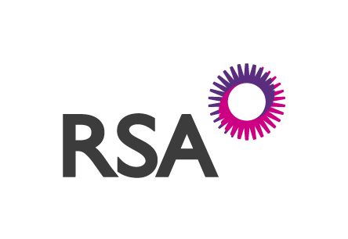

MARINE CLAIM NOTIFICATION

Completion of this form and the supplying of all applicable supporting documentation as described overleaf will enable us to deal with your claim in a timely manner.

Please return this form and documentation requested to RSA at the contact details below or via your Broker for onward transmission.

Please return the completed form to: RSA NI Ltd
Marine Claims Department
Law Society House
90-106 Victoria Street,
Belfast
BT1 3GN

Telephone No: 028 90320190
Facsimile No: 028 90327 582
Email: commercialclaims@ni.rsagroup.com

Policyholders Name

Policy Number

Date of Loss , Full circumstances and nature & extent of loss or damage

Amount Claimed

Conditions of Carriage:
RHA; CMR etc

PLEASE NOW ATTACH THE RELEVANT DOCUMENTATION AS OUTLINED OVERLEAF.

Insurance is authorised and regulated by the Financial Conduct Authority (309296), Registered office is Law Society House, 90-106 Victoria Street, Belfast BT1 3GN

GENERAL  - Claim Form  - Letter of claim from customer  - Claimant’s instruction to Insured.  - Claim Invoice, Freight Invoice, and, Commercial Invoice (to validate cargo value & weight)  - Signed Delivery/Consignment Note (by driver and on delivery)  - Photographs  - Terms and conditions of Carriage.  - How are conditions notified to the customer?  - Copy of contract? (if differing from standard terms) | TEMPERATURE RELATED INCIDENTS:  - Fridge unit download - highlight time of collection and delivery.  - Engineers report on the cause of the malfunction?  - Pre loss servicing history (fridge engineer)  - Instruction from claimant illustrating required carriage temperature for load
SALVAGE / DISPOSAL  - Disposal costs  - Realised sale price. | THEFT FROM VEHICLES  - Police Details (Crime Reference, Station Address, Officer, Crime Reference)  - Driver Statement (Signed and Dated)  - Was the trailer parked overnight in a secure parking area? If so, where? If not, why not?  - Details as to where the vehicle was left parked. Including google map, and, street view if no photos available  - Details of security measures in operation on the vehicle at the time  - Copy of repair estimate for any damage caused to the vehicle  - Vehicle tachograph  - Satellite tracker download
Upon receipt of any consignment you should:
- check the consignment for both quantity and condition
- if this is not possible then the consignment / delivery note should be claused: “SIGNED FOR QUANTITY – CONTENTS UNCHECKED”
- Examine container/trailer seals to ensure they are intact and the seal numbers match those on the transport document. Any discrepancy must be recorded on the delivery note.

At RSA NI we aim to provide a speedy and efficient claims settlement service and while each claim will be considered on its own individual circumstances we do aim to process low value claims efficiently upon receipt of the supporting documents. This is not an exhaustive list but covers most of the common required documents to ensure your claim is resolved as quickly as possible. Some claims may require additional investigation and we may instruct an independent adjuster to assist our enquiries.

Insurance is authorised and regulated by the Financial Conduct Authority (309296), Registered office is Law Society House, 90-106 Victoria Street, Belfast BT1 3GN

